**Business question justification corresponding to data marts shown above**

Please find the explanation of how we can answer all the five business question using the above two schemas below.

### BQ 1: What is the trend of wine sales during Christmas holiday season?

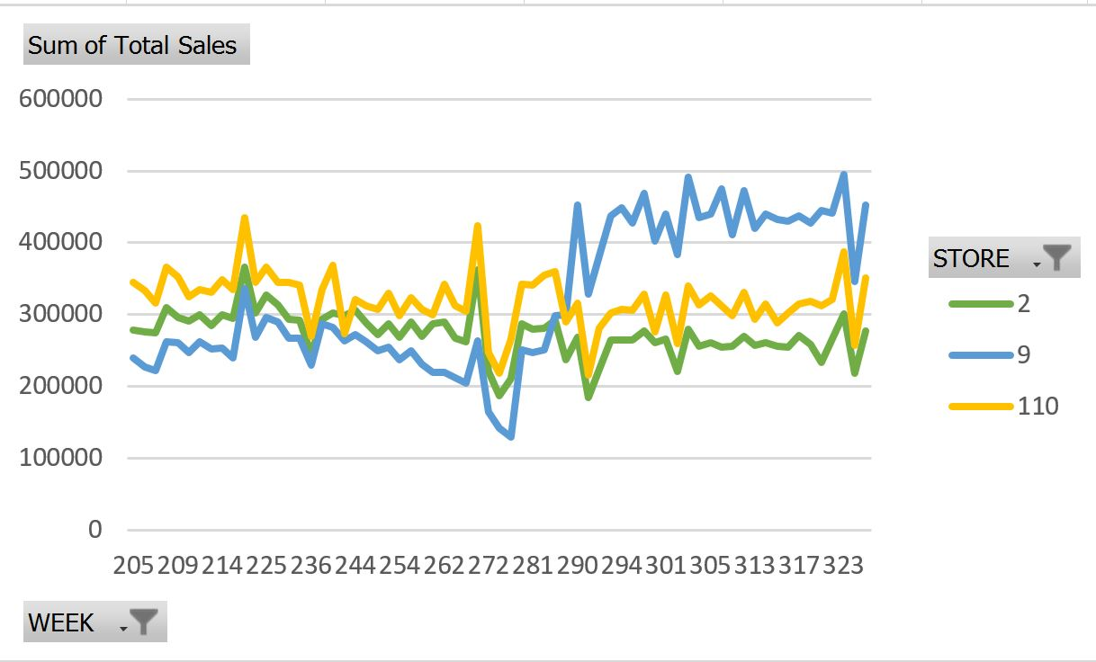

This business question is addressed by analyzing the Wine sales during the Christmas weeks as shown in the above graph. Same analysis can also be done with the Schema-1 shown in the above report. Here the product under consideration is Wine, information related to that can be obtained from PRODUCT_DIM dimension table, and Week related information could be taken from WEEK attribute loaded in TIME_DIM dimension table. Wine Sales related information corresponding to each week during Christmas week can be mapped from SALES_FACT fact table in Schema 1.

### BQ 2: Which stores have more popularity among kids and elderly groups?

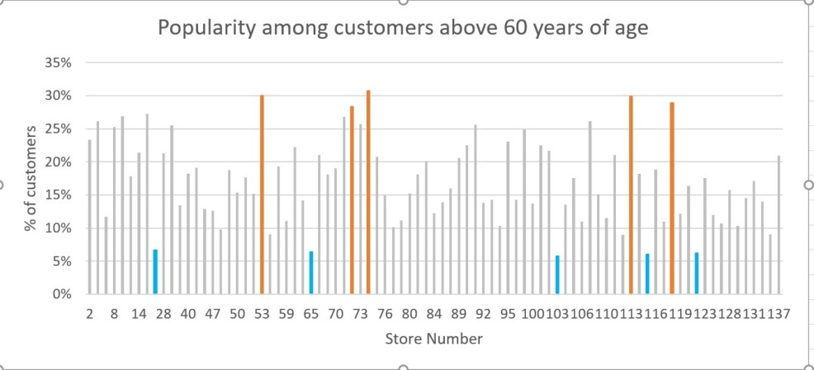

Schema 2 can be used for analyzing this business question. Number of people below age 9 (BELOW_9_ %) and above 60(ABOVE_60_ %) are attributes in DEMOGRAPHIC_DIM dimension table and Store Number plotted the above graph can be loaded from attribute STORE_NUMBER from STORE_DIM dimension table. Comparing the two values, the number of store visits, CUSTOMER_COUNT, is obtained from STORE_VISITS_FACT fact table. Above graph will help us analyze just the popularity among people above age 60. For answering this business question completely, popularity of stores among kids and elderly group will be analyzed separately.

### BQ 3: Which stores attract people who earn below poverty line?

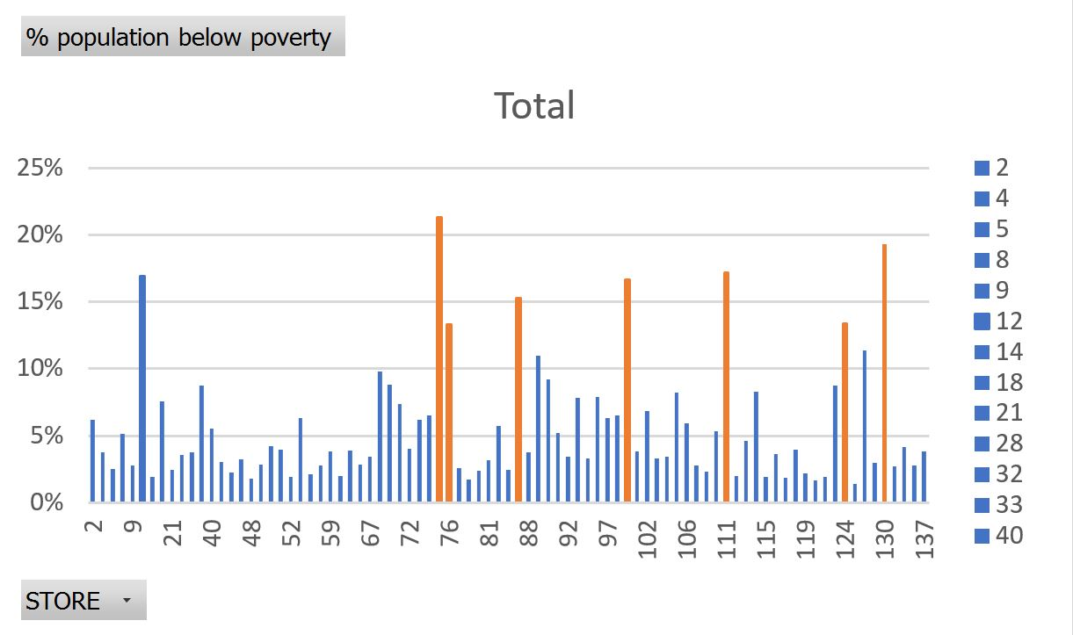

This business question can be analyzed similar to Business Question 2. Same schema 2 can be used for analysis. IS_POOR attribute is available in DEMOGRAPHIC_DIM table and store number STORE_NUMBER is obtained from STORE_DIM table. For each corresponding values of STORE_NUM and IS_POOR we can get the CUSTOMER_COUNT from STORE_VISITS_FACT table given in the schema. This data can be used to analyze store attraction among people below poverty line.

BQ 4: **What is the effect of introducing coupons on total number of customer visits?**

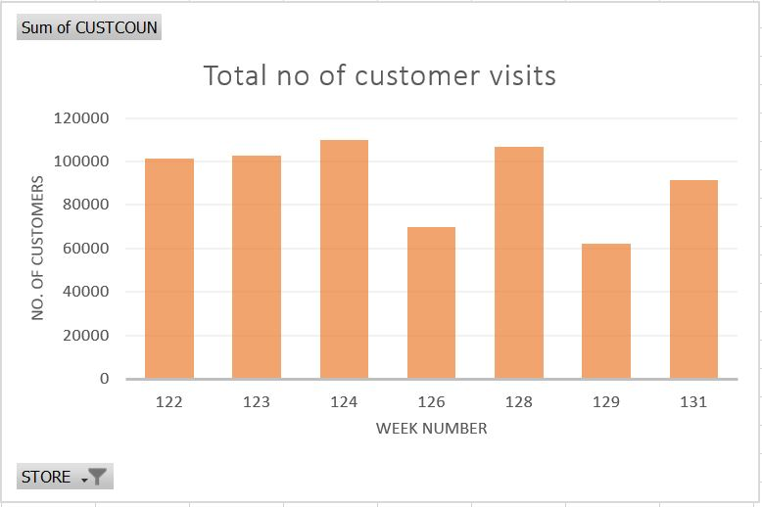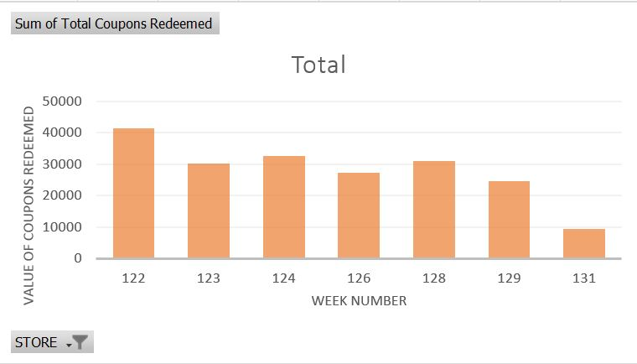

This is comparatively complex business question to analyze even though it is easy to understand. For analyzing the question we need to plot and compare the Total number of customer visits and Total number of coupons redeemed on a weekly basis. Comparing the trend in both the graph’s we can reach at a conclusion of effect of coupons on customer visits. So here the Schema 2 can be used again for analysis. CUSTOMER_COUNT attribute from STORE_VISITS_FACT fact table can be plotted against the WEEK attribute loaded in TIME_DIM dimension table form the schema. Similarly, for plotting the second graph we need calculate the value derived from the summation of coupon sales from different product category, which is given in CCount table. This summed up value is stored in COUPON_DIM dimension table as COUPON_REDEEMED attribute. COUPON_REDEEMED attribute from COUPON_DIM dimension table can be used for plotting the second graph. So now with the two graph’s plotted from the data loaded to dimension tables and fact tables we can easily find the effect of introducing coupons in total number of customer visits.

### BQ 5: What is the trend of a product demand in different price-tiers?

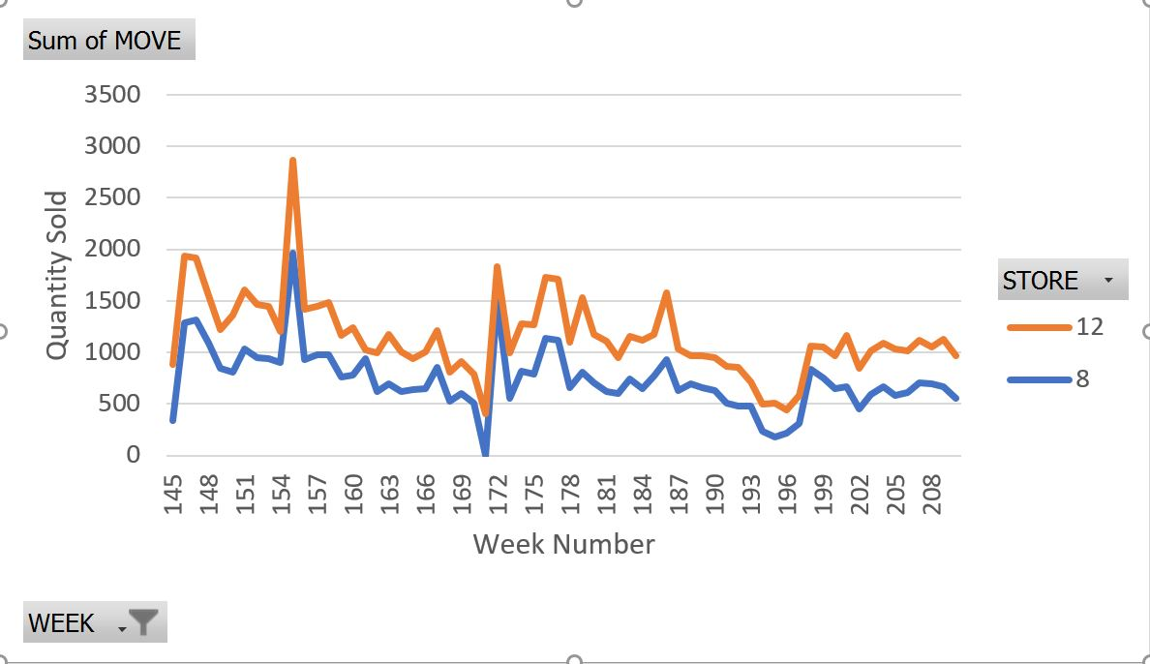

This business question can be answered by plotting the weekly sales data of each Shop tiers (A,B.C) . For this Business question, we can use schema 1. In schema 1, the PRICE_TIER information is loaded in STORE_DIM dimension table and WEEK related data is stored in TIME_DIM dimension table. All the sales related information for all the shop price tiers can be collected from the SALES_AMOUNT attribute from SALES_FACT fact table. This information is plotted for each shop tiers and the distribution of sales in each shop tier can easily be analyzed from the plot.

**Conclusion**

From the above explanation it is clear that all selected business questions can be analyzed with 2 schema diagrams shown above. Both schemas include two fact tables -STORE_VISITS_FACT, SALES_FACT and 5 dimension tables - STORE_DIM, TIME_DIM, PRODUCT_DIM, DEMOGRAPHIC_DIM, and COUPON_DIM. Current fact tables, dimension tables and fact tables in each schema is designed to give faster performance. But still the performance can be increased further by using aggregate fact tables if needed. Need for the aggregate fact tables can be analyzed after properly loading the required data from all the 4 tables to the fact and dimension tables designed in the current schemas and running queries on top of it. Need for the aggregation fact tables will be decided on the upcoming stages of the project.